PERFORMANCE TEST REPORT

**Project: Trainer Management System**

Objective: Perform load test of the the “Trainer Management System” portal and identify the performance of the application for different functionalities under various loads

SCENARIO 1: User opens the website and uses all the navigation menu links LOGIN, SIGNUP, HOME and then performs the Sign Up process.

Test#1: 50 Users (20s)

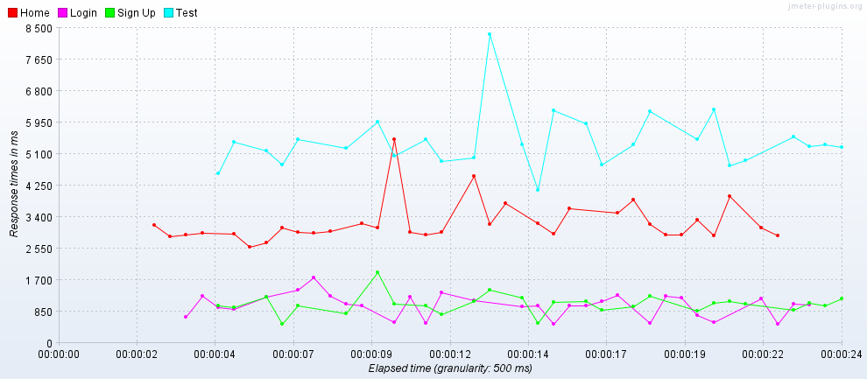

Test#2: 100 Users (20s)

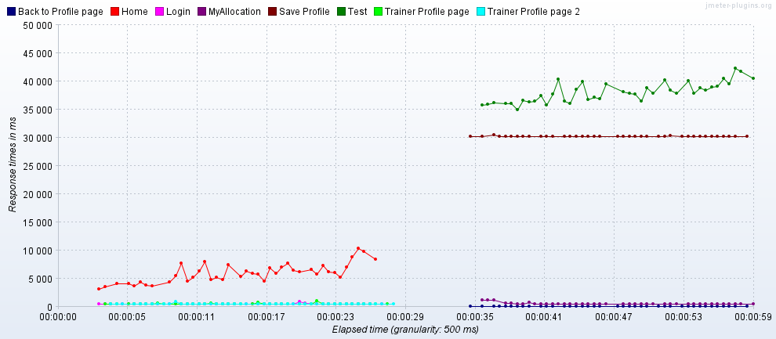

Test#3: 150 Users (20s)

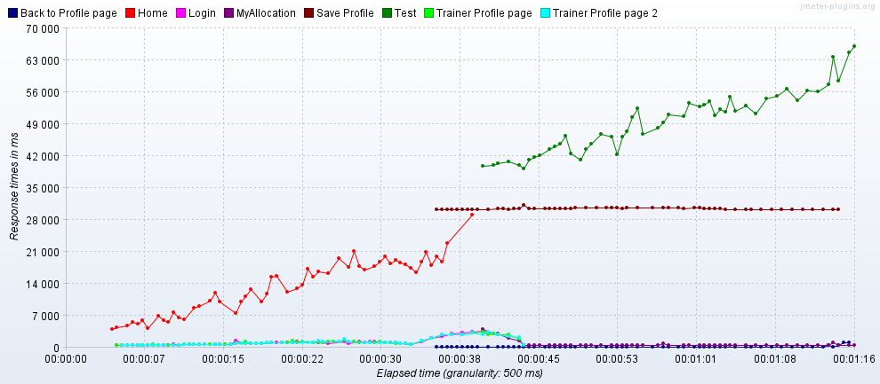

Based on the analysis of the response time graphs for the application under various loads for Scenario 1, we can see that the system is stable under loads around 50 users whereas the response time shows considerable increase with load. The Home page seems to have the highest response time due to visual elements available on the homepage like the video and image carousel. We can also see that the Trainer profile edit and save option has a considerably high response time compared to the rest of the application.

SCENARIO 2: Trainer login and edit profile data and then verifies the training allocated to user

Test#1: 50 Users (20s)

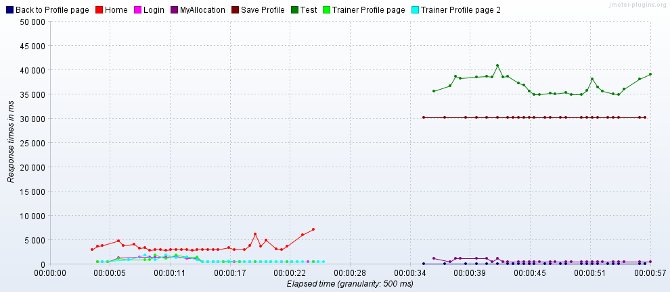

Test#2: 100 Users (20s)



Test#3: 150 Users (20s)



Based on the analysis of the response time graphs for the application under various loads for Scenario 1, we can see that the system is stable under loads around 50 users whereas the response time shows considerable increase with load. The Home page seems to have the highest response time due to visual elements available on the homepage like the video and image carousel. We can also see that the Trainer profile edit and save option has a considerably high response time compared to the rest of the application.

SCENARIO 3: Approving a newly enrolled Trainer from the admin dashboard and then confirming if the new trainer was added to the list of approved trainers

Test#1: 50 Users (20s)

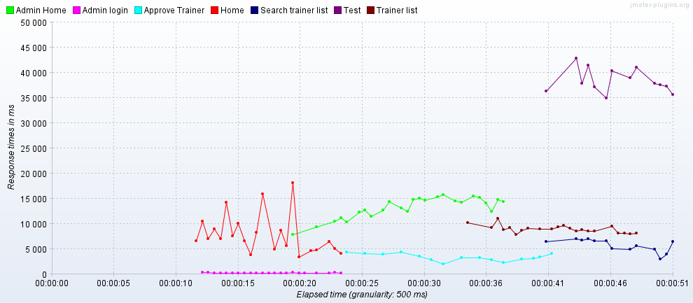

Test#2: 100 Users (20s)

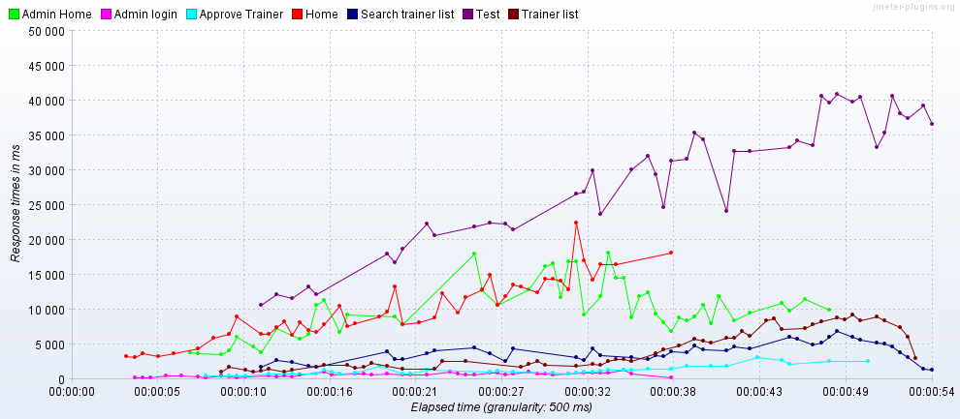

Test#3: 150 Users (20s)

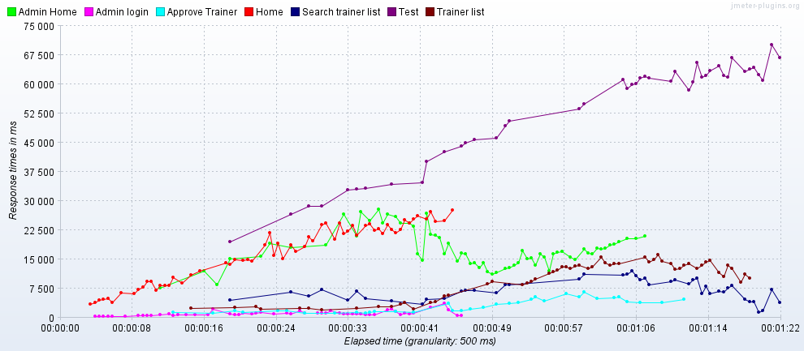

Based on the analysis of the response time graphs for the application under various loads for Scenario 1, we can see that the system is stable under loads around 50 users whereas the response time shows considerable increase with load. The Home page seems to have the highest response time due to visual elements available on the homepage like the video and image carousel. We can also see that the Trainer profile edit and save option has a considerably high response time compared to the rest of the application. There is also clear indication of delay in retrieving trainer information from the database, leading to the higher response time for pages like the admin dashboard and approved trainer list pages which require the entire table to be loaded before the search and allocate functionalities can be used.

SCENARIO 4: Allocating a trainer from the Allocate list and scheduling a session for the trainer and then verifying if the trainer was allocated successfully.

Test#1: 50 Users (20s)

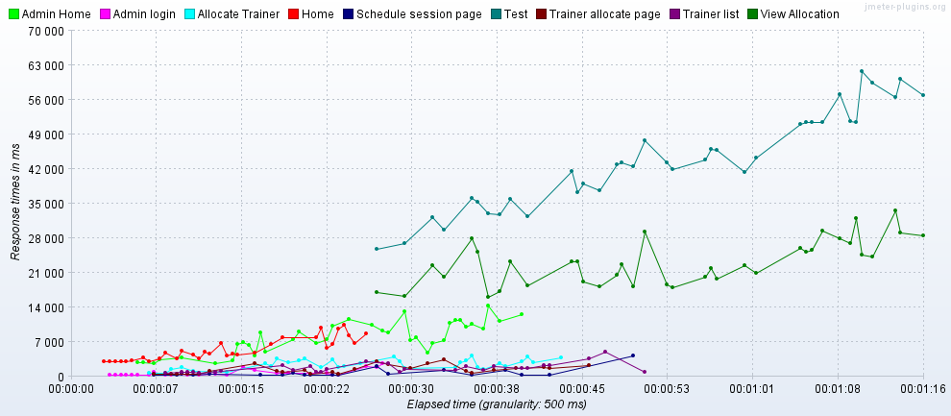

Test#2: 50 Users (20s)

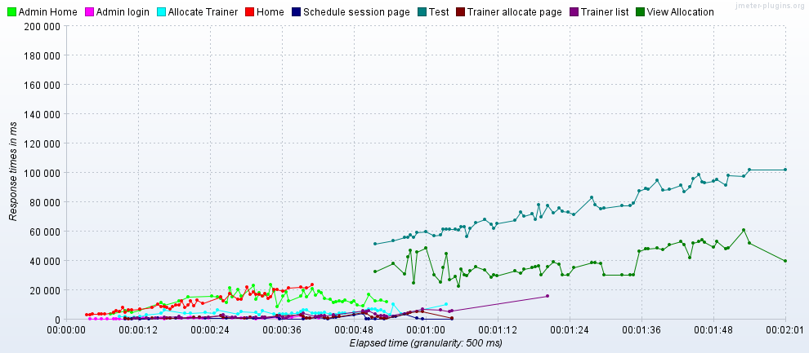

Test#3: 150 Users (20s)

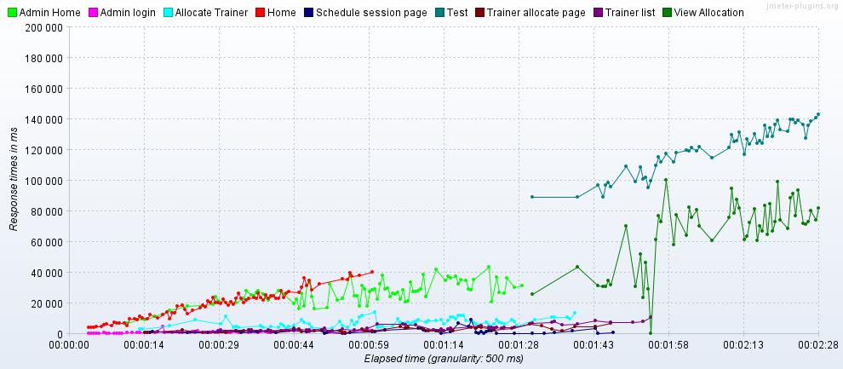

Based on the analysis of the response time graphs for the application under various loads for Scenario 1, we can see that the system is stable under loads around 50 users whereas the response time shows considerable increase with load. The Home page seems to have the highest response time due to visual elements available on the homepage like the video and image carousel. We can also see that the Trainer profile edit and save option has a considerably high response time compared to the rest of the application. There is also clear indication of delay in retrieving trainer information from the database, leading to the higher response time for pages like the admin dashboard and approved trainer list pages which require the entire table to be loaded before the search and allocate functionalities can be used. We can also see that the “View Allocation” page shows an equally long response time as the Homepage due to the huge amount of data being pulled from the database to populate the table on page.